Design contest to find the first global
Press Release
Antibiotic Resistance Symbol launched
Publication date: 18th November 2019
EU-JAMRAI launches, during the celebration of the European Antibiotic Awareness Day (EAAD) in Stockholm, a design contest to find the symbol that best represents the global threat of antibiotic resistance.

On the occasion of the celebration of the European Antibiotic Awareness Day (EAAD) in Stockholm, the Joint Action on Antimicrobial Resistance and Healthcare-Associated Infections (EU-JAMRAI) launches a design contest to find a symbol of the threat against antibiotic resistance. This contest is not about creating another logo. EU-JAMRAI is looking for something tangible that anyone can make at home and everyone, anywhere can wear; like the AIDS ribbon.
The contest is open to all individuals no matter their background or age. Participants who like science, have a creative mind or want to make a change raising awareness about the global threat of antibiotic resistance are welcomed to enter this contest. Entries will be accepted until the 31st of March 2020, and the winner will be announced next summer. All the contest rules are available at www.eu-jamrai.eu.
The jury will be multidisciplinary and multisectoral, including representatives from EU-JAMRAI and the European Centre for Disease Prevention and Control (ECDC), other members of its stakeholder forum, scientists, regulatory bodies, patient organizations.
This design contest is one of the activities developed by EU-JAMRAI to promote the prudent use of antibiotics in order to stunt the development of resistant bacteria and keep these wonder drugs effective. Co-funded by the European Union Health Programme, EU-JAMRAI brings together 44 partners and more than 40 stakeholders. Under the motto “bringing the gap between declarations and actions”, EU-JAMRAI mission is fostering synergies among EU Member States by developing and implementing effective One Health policies to keep antibiotics working.
Antibiotics are medicines used to prevent and treat bacterial infections. As a result of overuse (and misuse) of antibiotics, in both humans and animals, bacteria become antibiotic-resistant, developing the ability to resist these medicines designed to kill them. Without working antibiotics, routine surgery like hip replacements, common illnesses like diarrhea, and minor injuries from accidents, even simple cuts, can become life-threatening.
Antibiotic-resistant infections do not recognize geographic or human–animal borders and can affect anyone. But we can solve this problem by taking action now to keep the antibiotics we already have, in order to protect ourselves, our families and our communities.
The purpose of EU-JAMRAI Antibiotic Resistance Symbol Contest is encouraging everyone to take action now by taking part in this competition and giving visibility to this rising public health problem.
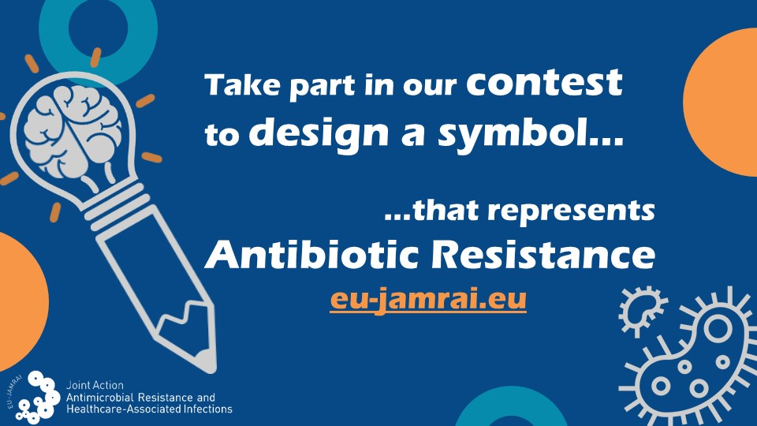

More information and promotional materials: https://eu-jamrai.eu/symbol-contest/
Social Media: @EUjamrai
Contest hashtag: #antibioticresistancesymbol
European Antibiotic Awareness Day (EAAD): https://antibiotic.ecdc.europa.eu/en
EU-JAMRAI Communication Office Contact: aemps.jamrai@aemps.es

This document arises from the Joint Action on Antimicrobial Resistance and Healthcare-Associated Infections (EU-JAMRAI), which has received funding from the European Union, in the framework of the Health Program (2014-2020) under the Grant Agreement Nº761296. Sole responsibility lies with the author and the Consumers, Health, Agriculture and Food Executive Agency is not responsible for any use that may be made of the information contained herein.
The total or partial reproduction of this content is authorized as long as the source (EU-JAMRAI) is expressly mentioned.

